**COSC 223 FILE HANDLING ASSIGNMENT**

# ***Group Members:***

1. Victor Mutugi Kathenya – EB1/56061/21
2. Agnes Mabeya -EB1/56047/21
3. Peter Maina – EB1/42996/19
4. Muchiri Timothy Maina– EB1/56037/21
5. Collins Mwaura Wambui-EB1/56094/21
6. James Maureen Kambua -EB1/56648/21
7. Purity Nafula – EB1/56079/21
8. Leah Achieng’ – EB1/56068/21
9. Phoelix Otieno Mboya – EB1/56138/21
10. Felix Kibet Rotich – EB1/56106/21

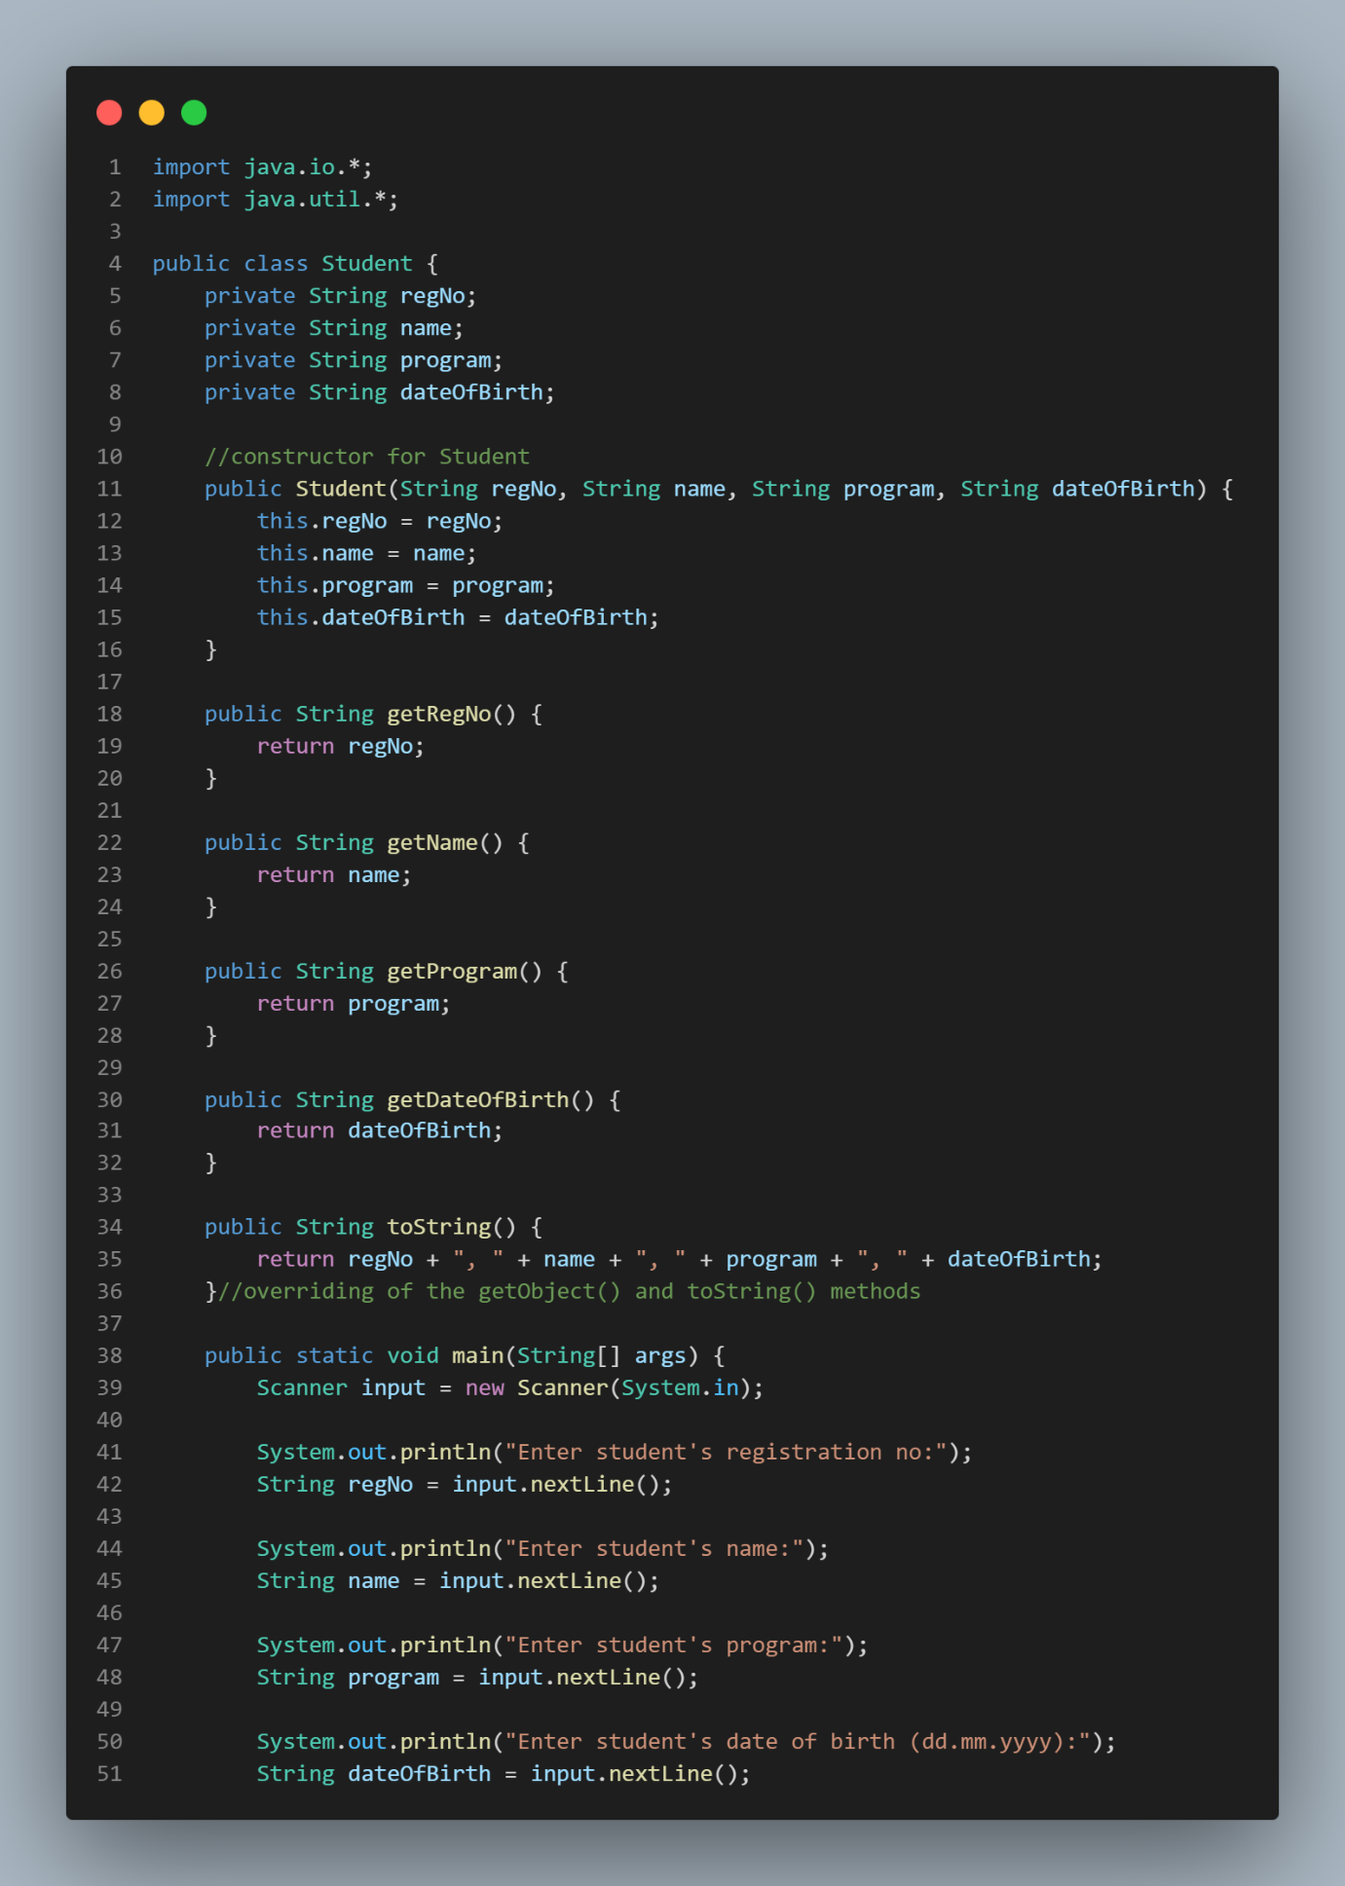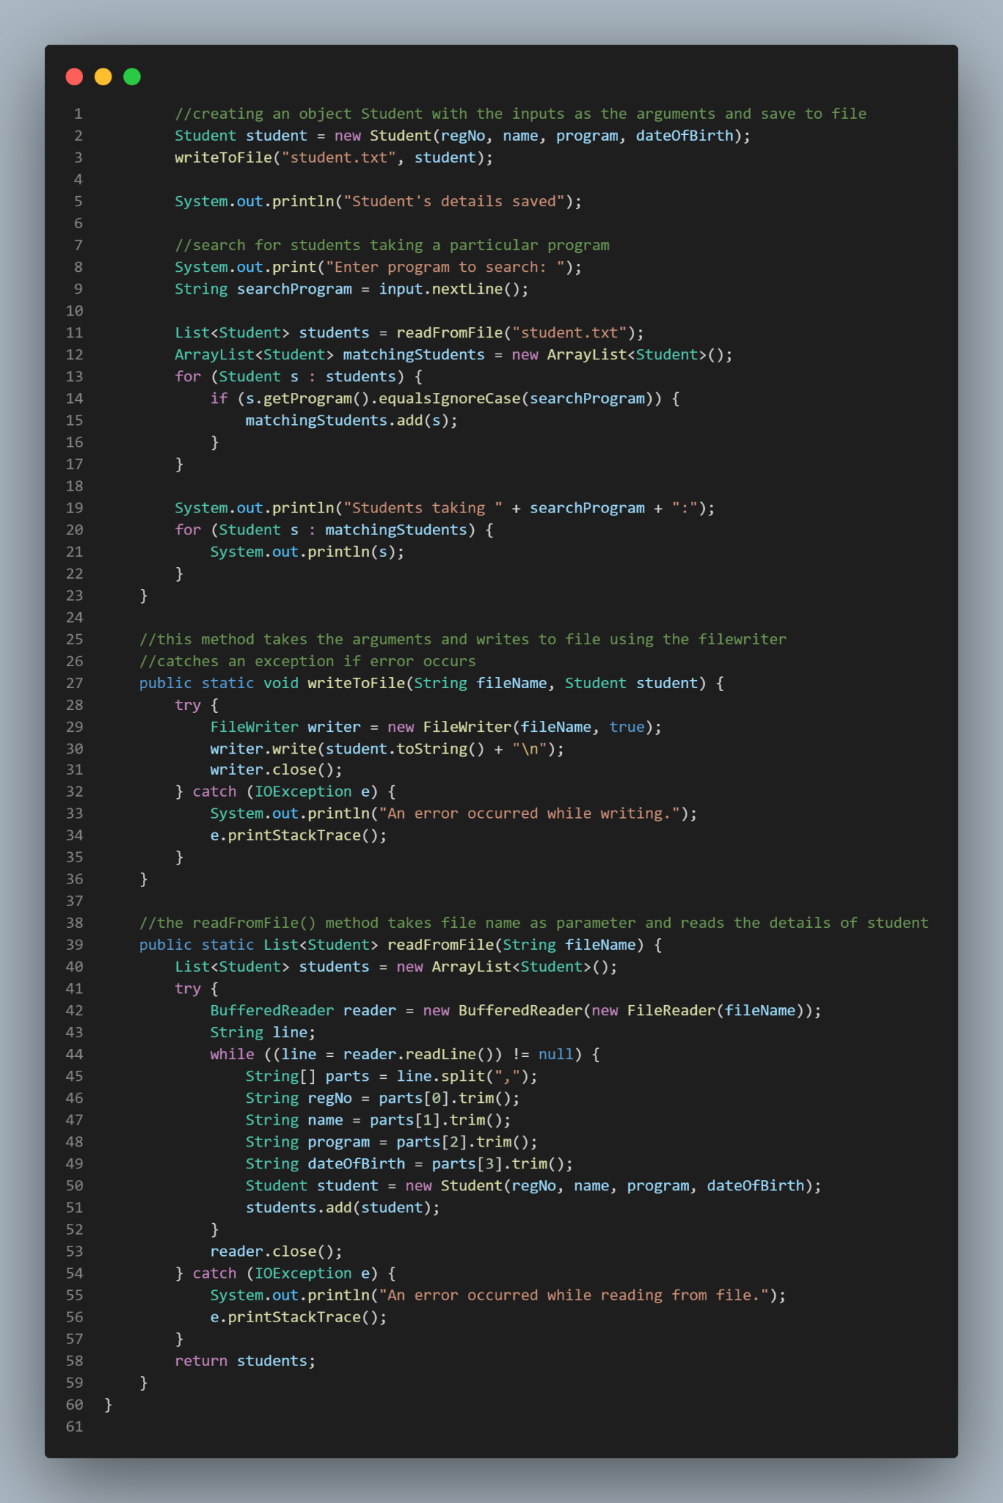

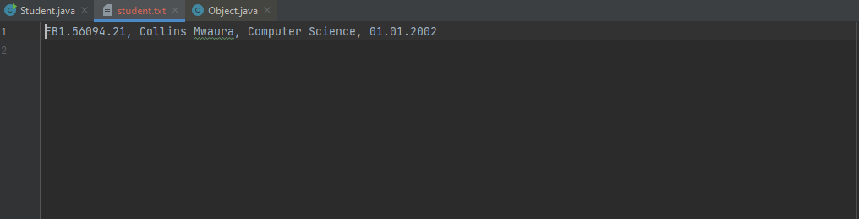

import java.io.*;

import java.util.*;

public class Student {

    private String regNo;

    private String name;

    private String program;

    private String dateOfBirth;

    //constructor for Student

    public Student(String regNo, String name, String program, String dateOfBirth) {

        this.regNo = regNo;

        this.name = name;

        this.program = program;

        this.dateOfBirth = dateOfBirth;

    }

    public String getRegNo() {

        return regNo;

    }

    public String getName() {

        return name;

    }

    public String getProgram() {

        return program;

    }

    public String getDateOfBirth() {

        return dateOfBirth;

    }

    public String toString() {

        return regNo + ", " + name + ", " + program + ", " + dateOfBirth;

    }//overriding of the getObject() and toString() methods

    public static void main(String[] args) {

        Scanner input = new Scanner(System.in);

        System.out.println("Enter student's registration no:");

        String regNo = input.nextLine();

        System.out.println("Enter student's name:");

        String name = input.nextLine();

        System.out.println("Enter student's program:");

        String program = input.nextLine();

        System.out.println("Enter student's date of birth (dd.mm.yyyy):");

        String dateOfBirth = input.nextLine();

        //creating an object Student with the inputs as the arguments and save to file

        Student student = new Student(regNo, name, program, dateOfBirth);

        writeToFile("student.txt", student);

        System.out.println("Student's details saved");

        //search for students taking a particular program

        System.out.print("Enter program to search: ");

        String searchProgram = input.nextLine();

        List<Student> students = readFromFile("student.txt");

        ArrayList<Student> matchingStudents = new ArrayList<Student>();

        for (Student s : students) {

            if (s.getProgram().equalsIgnoreCase(searchProgram)) {

                matchingStudents.add(s);

            }

        }

        System.out.println("Students taking " + searchProgram + ":");

        for (Student s : matchingStudents) {

            System.out.println(s);

        }

    }

    //this method takes the arguments and writes to file using the filewriter

    //catches an exception if error occurs

    public static void writeToFile(String fileName, Student student) {

        try {

            FileWriter writer = new FileWriter(fileName, true);

            writer.write(student.toString() + "\n");

            writer.close();

        } catch (IOException e) {

            System.out.println("An error occurred while writing.");

            e.printStackTrace();

        }

    }

    //the readFromFile() method takes file name as parameter and reads the details of student

    public static List<Student> readFromFile(String fileName) {

        List<Student> students = new ArrayList<Student>();

        try {

            BufferedReader reader = new BufferedReader(new FileReader(fileName));

            String line;

            while ((line = reader.readLine()) != null) {

                String[] parts = line.split(",");

                String regNo = parts[0].trim();

                String name = parts[1].trim();

                String program = parts[2].trim();

                String dateOfBirth = parts[3].trim();

                Student student = new Student(regNo, name, program, dateOfBirth);

                students.add(student);

            }

            reader.close();

        } catch (IOException e) {

            System.out.println("An error occurred while reading from file.");

            e.printStackTrace();

        }

        return students;

    }

}